**BOOK SHOP MANAGEMENT**

Enter the book details in Table. which you wanted to add and click SAVE.

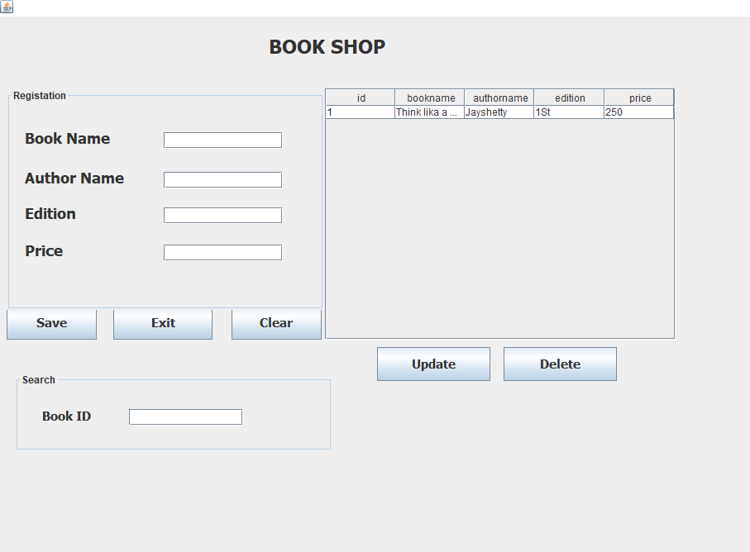

The records of the books are added in the table and displayed in the window.

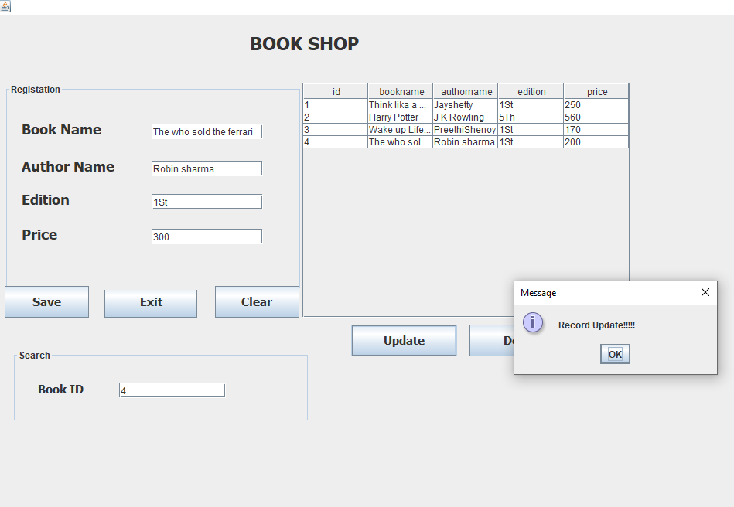

Search for the book ID which you wanted to update

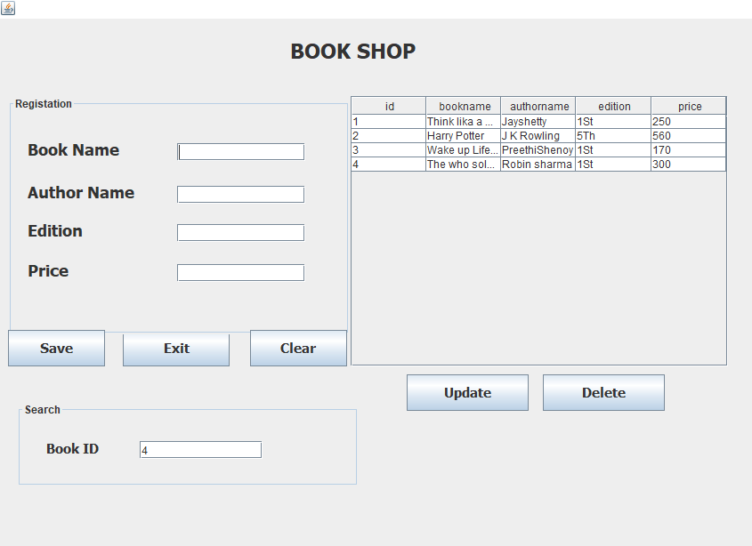

The Book Record is Updated in the table

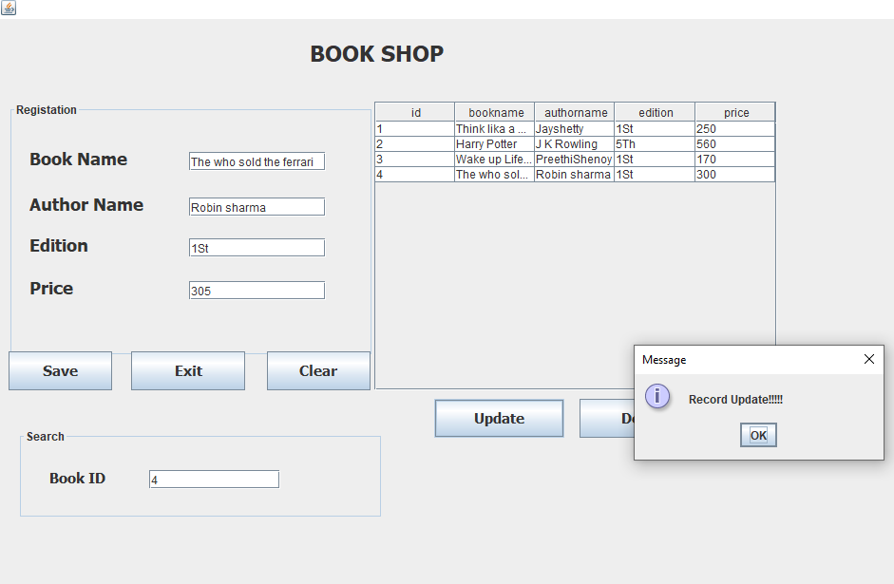

Now click Exit and logout

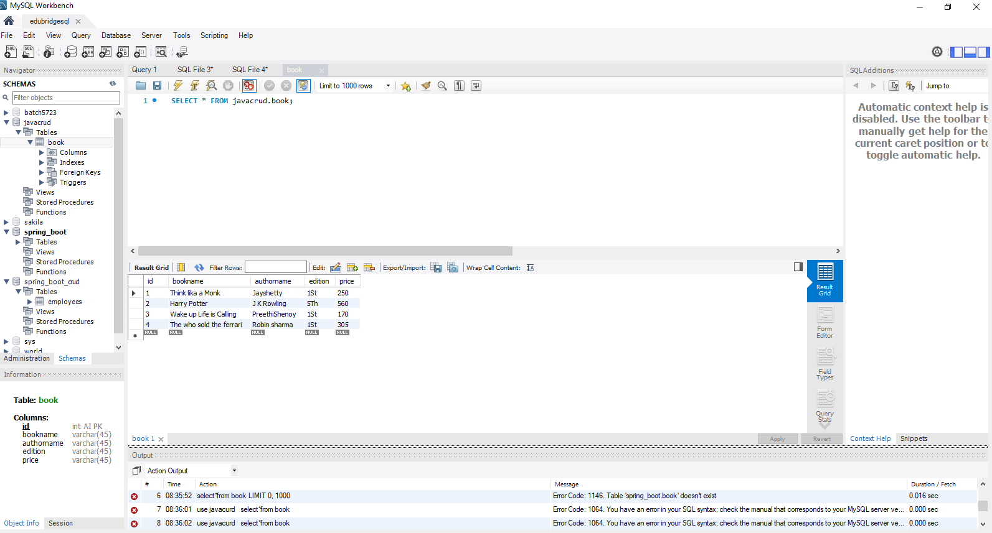

Now Book details were updated in MYSQL.